Master Greenhouse Document

Table of Contents
Mission Statement
Components

Mission Statement
Based on what I remember, The greenhouse monitoring project is part of the greenhouse research facility at the University of California, Santa Cruz. As part of their project, the faculty needs to monitor humidity, ambient light, and temperature to complete their research.

To make sure the greenhouse is healthy, we need to have sufficient power analytic data. We must ensure the greenhouse is generating a sufficient amount of power to power the greenhouse sensors they need to monitor the greenhouse conditions with.

If something goes wrong with the batteries that can be solved remotely (e.g. the batteries are too hot), we must have certain features installed to the greenhouse. The batteries will get hot, so we must install a fan. It will actuate when the battery management system detects the batteries are too hot. If something goes wrong with the batteries or solar panels that cannot be solved remotely, it should alert the faculty.

Additionally, the faculty would like to have the ability to have an AC outlet. The AC outlet needs to be monitored so nobody uses it unnecessarily.

The faculty, as a bonus feature, would like to be able to host a class in the greenhouse. In order to host a class, they need the students to be able to monitor any number and kind of sensors.

All of this data must be stored on a UCSC server and database. In order for the data to get from the greenhouse to the UCSC server, we must have an internet connection. There is no Wi-Fi connection at the greenhouse, so we must have a cellular data plan. A 2G data plan should be sufficient for our purposes.

Goals:

1.) Monitor battery data and solar panel data from TSMPPT and BMS systems.

2.) Gather data about the greenhouse:
- Choose a light sensor.
- Build an enclosure for that sensor.
- Choose a temperature and humidity sensor.
- Build an enclosure for that sensor.
- Harvest that data

3.) Save that data to a database by sending it from the Raspberry Pi to a server somewhere in UCSC.

4.) Have an option to have student sensors. Have a separate microcontroller to gather student sensor data, then have that microcontroller send that data over Bluetooth to the master microcontroller.

5.) Have a website display Humidity, Light, Temperature, TSMPPT data, BMS data when requested by a client. Have that same website have another page to check on their sensors.

6.) Have an engineering schematic documenting how all the parts go together.

7.) Have a wiring diagram documenting how to put all the parts together. Much like a LEGO manual.

Details:

Reference for light sources:

120000 lux is the brightest sunlight
111,000 lux is bright sunlight
109,870 lux is AM 1.5 global solar spectrum sunlight
20,000 lux is shade illuminated by entire clear blue sky, midday.
1,000-2,000 lux is a typical overcast day, midday.
<200 lux: extremely stormy day, midday.

Specifications for Light for our light sensor:

Minimum Ambient Light Resolution:
(at night)
0.0036 lx/ct.

Maximum Ambient Light Resolution:
(in bright sunlight)

1.8431 lx/ct

Ambient Light Range:
0 to 120,000 lux

Operation Temperature Range:
-25 C to +85 C
Detectable minimum luminescence:
0.0072 lux
Detectable maximum luminescence:
120,000 lux

Precision:
100 Hz and 120Hz flicker noise rejection

Data tolerance:
<= 10%.

10% errors only occur when the light source is coming from a source that has strong infrared content, such as a halogen lamp.

Minimum sample time:
25ms (bright sunlight)

Maximum Sample time:
800ms (nighttime)

References:
https://www.vishay.com/docs/84286/veml7700.pdf
https://en.wikipedia.org/wiki/Daylight

Specifications for Humidity:

I don’t really know how humidity works.

Specifications for Temperature:

I don’t really know how temperature works.

Top-Level Block Diagram

See “master_schematic_rev_1.1.pdf”

Components

MPPT Box
This is an MPPT controller.
Input:
Voltage from Solar Panels
Output:
Constant voltage.
Microcontroller Data
We have a Tristar Morningstar MPPT Solar Charge controller.
Model Number: TS-MPPT-60.
We’ve got an owners manual.
It’s capable of outputting data through these formats:
RS-232
Morningstar Meter Bus
EIA-485 (formerly RS-485)

RS-232 Configurations
BAUD rate: 9600
Data bits: 8
Start bit:
Stop bit:
No parity bit
The problem: RS-232 outputs 13V for high bit and -13V for low bit.
We need to convert from RS-232 to TTL.
RS-232 is a format suited for long-range communiction.
TTL is a format suited for microcontrollers.
We can use a MAX232 IC chip to do the job.

BMS Box
We need a battery management system.
Input:
Voltage from Tristar MPPT Solar Charge Controller.
Output:
Microcontroller Data, Constant Voltage.
If the BMS detects voltage from the MPPT controller, do this:
If the MPPT power is higher than needed by the greenhouse, route the amount of power necessary from the MPPT to the greenhouse, and the rest of the power goes to the battery. If the battery has enough space to receive the energy, send a message to the microcontroller saying the batteries are charging. If not, then send a message to the microcontroller saying the batteries are fully charged. Somehow, we have to get rid of this excess energy.
If the MPPT power is lower than needed by the greenhouse, route all the power from the MPPT To the greenhouse, and compensate the difference of power from the batteries. If the batteries don’t have enough voltage, then send a message to the microcontroller saying we don’t have enough power to run the greenhouse.
If there’s no MPPT power, then draw the necessary amount of power from the batteries.

Batteries
At one point, the 2017 team considered Lead Acid batteries, Nickel Cadmium batteris, Nickel Metal Hydride Batteries, and Lithium Ion batteries. Here are all of their specifications:
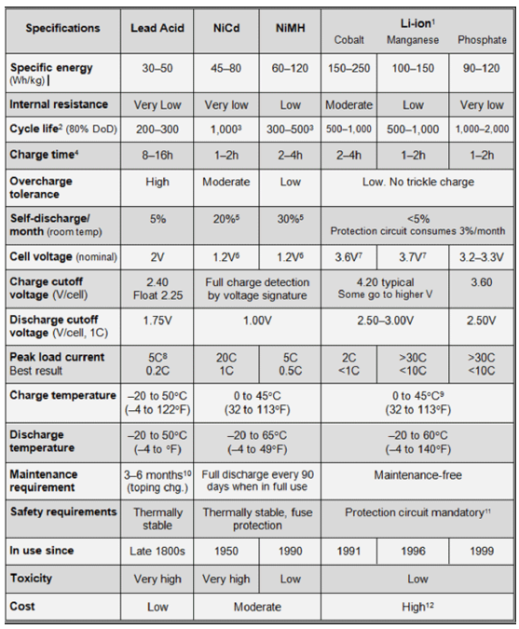
The ones that ended up being picked are lithium-ion batteries.
Model number: IEP71/180/278-CA180FT
Nominal voltage: 3.2V
Rated Capacity: 180Ah
Rated Energy: 576Wh
I think it’s this thing right here:
https://www.alibaba.com/product-detail/3-2V-180Ah-Battery-200Ah-LiFePO4_60769977420.html?spm=a2700.7724857.normalList.14.22c11fa70X3Jaa

Sine Wave Inverter Box
Input: 12V DC voltage
Output: 110V 50Hz AC voltage

Microcontroller Box

Solar Panels
As of August 2017:
The solar panels are branded LUMO and produced by Soliculture. They have non-continuous photovoltaic cells which allow light to pass through the clear glass panels so that plants can still harvest a majority of the light. Additionally, they act as replacements for the glass roof panels of the greenhouse. (This is a terrible idea, guys. It has a bunch of leaks that need to be fixed, now.)
Company: Soliculture
Panel Dimensions: 64” x 22”
Mounting: Panels slot into slides on the roof and are held in place by an aluminum strap on the face that meets the wall.
Older Panels:
Quantity: 22
Cloudy Day:
V_{OC} = 29.9V, I_{SC} = 0.22A, Power: 6.6W
Sunny Day:
East Side: V_{OC} = 31.3V, I_{SC} = 0.50A, Power: 25.4W
West Side: V_{OC} = 31.3V, I_{SC} = 0.81A, Power: 25.4W
Newer Panels:
Quantity: 10
Cloudy Day:
V_{OC} = 6.75V, I_{SC} = 2.4A, Power: 16.2W
Sunny Day:
V_{OC} = 6.84V, I_{SC} = 4.3A, Power: 29.4W
Panel Specifications from Manufacturer:
V_{OC} = 8.00V, I_{SC} = 12.30A, V_{mp} = 6.30V, I_{mp} = 10.80A
Power: M_{pp} = 68W
This is the average panel performance.

Input:
Sunlight
Output:
Average of 68W of power delivered to the MPPT controller.
Speculations for 2018:
Tela wishes for a way to track solar power. We need voltage, current, power, and light intensity. This is what she will get.

Website

Wiring Diagram

